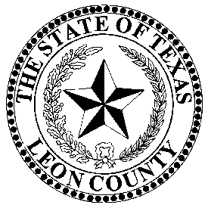 | LEON COUNTY TAX ASSESSOR/COLLECTOR
 | VICTORIA WILLIS
P.O. Box 37, 155 N Cass Street, Centerville, Texas 75833 903/536-2543 903/536-2431-FAX
Victoria.willis@co.leon.tx.us, leoncountytax.org,

INSTRUCTIONS FOR WAIVER OF PENALTY AND INTEREST PER SECTION
33.011 OF THE TEXAS PROPERTY TAX CODE

ONLY FOR SCHOOL ACCOUNTS THAT ARE IN LEON COUNTY

- The account must be paid in full (includes penalty, interest and collection fees), within 21 days of knowing of the delinquency before a request for waiver of penalty, interest and collection fees would be considered by the School Board.

- The taxpayer must issue a written request for waiver of penalty, interest and collection fees to:

Superintendent, Carol Dickey
Centerville ISD
813 S Commerce
Centerville, Texas 75833

Superintendent, Justin Vercher
Normangee ISD
P.O. Box 219
Normangee, Texas 77871

Superintendent, Russell Holden
Oakwood ISD
631 N Holly
Oakwood, Texas 75855

Superintendent, Adam Ivy
Buffalo ISD
- dar Creek Rd
Buffalo, Texas 75831

- The request must include: Account number, legal description, year(s) in question, plus the taxpayer’s current mailing address and telephone number.

It is up to the taxpayer to provide substantial proof that an error was made by the Tax Office, the Central Appraisal District or any other provisions in Section 33.011 of the Texas Property Tax Code to allow the waiver of penalty, interest or collection fees.

- The Superintendent’s office will notify you of when you are scheduled to appear before the School Board.

***NOTE: The Leon County Tax Office records are open to the public. Our office is open from 8:00 AM to 4:30 PM Monday thru Friday. For extensive research, please call the Tax Office. The phone number is (903) 536-2543.

